Smart Energy Meter for Real-Time Tariff Calculation and Online Billing

*Sanjai M  
dept. of electrical engineering  
(of VIT chennai)  
VIT chennai   
(VIT university)  
Chennai,Tamil Nadu, India  
Sanjai.m2022@vitstudent.ac.in*

*Derick Blesswin J  
dept. of electrical engineering  
(of VIT chennai)  
VIT chennai   
(VIT university)  
Chennai,Tamil Nadu, India  
derickblesswin.j2022@vitstident.ac.in*

*Sidharth K  
dept. of electrical engineering  
(of VIT chennai)  
VIT chennai   
(VIT university)  
Chennai,Tamil Nadu, India  
sidharth.k2022@vitstudent.ac.in*

*Ramana Hanumanth S  
dept. of electrical engineering  
(of VIT chennai)  
VIT chennai   
(VIT university)  
Chennai,Tamil Nadu, India  
ramanahanumanth.s2022@vitstudent.ac.in*

*Inayathullaah Abdul Kareem  
Professor in dept. of electrical engineering  
(of VIT chennai)  
VIT chennai   
(VIT university)  
Chennai,Tamil Nadu, India  
inayathullah.a@vit.ac.in*

*Abstract*— Efficient energy management is essential for consumers and utility providers, especially in regions with structured taxation like India. This project presents a Smart Energy Meter that calculates electricity tariffs based on total energy consumption. The meter automates tariff computation and ensures transparent billing with continuous real-time updates. Once the tariff is paid at the end of the month, the total energy consumed resets for the next billing cycle. The system is designed to improve metering efficiency while reducing human intervention.

# Introduction

Traditional electricity meters require manual reading, leading to billing delays and inaccuracies. To address these issues, our Smart Energy Meter integrates real-time energy monitoring and automated tariff calculations based on the Indian electrical tax system. Using Arduino based hardware, the system provides live updates on energy consumption and tariff calculations, ensuring users have better control over their electricity usage. A display for tariff calculation and total energy consumed will be displayed automatically. The system is intended for both residential and commercial applications.

# Overall Block diagram and working

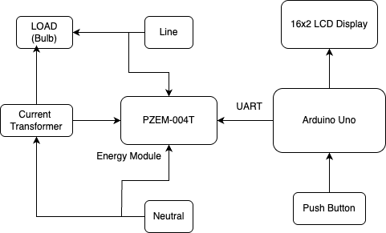

1. Power Supply and Initialization:

* When the system is powered ON, the Arduino Uno initializes all components.
* The PZEM-004T energy meter starts measuring voltage, current, and power from the connected load (bulb).

2. Current and Voltage Sensing:

* The current transformer (CT) in the PZEM-004T module detects the current flowing through the load.
* The voltage is measured directly from the mains supply.
* Using these readings, the PZEM-004T calculates power and energy consumption.

3. Data Communication (PZEM-004T to Arduino Uno):

* The PZEM-004T sends the measured values to the Arduino Uno via a serial communication protocol (Modbus over UART).
* The Arduino reads the raw data and processes it.

4. Data Processing and Display:

* The Arduino processes the received data and formats it for display.
* The 16x2 LCD screen updates in real-time to show:
  + Voltage (V)
  + Current (A)
  + Power (W)
  + Energy Consumption (kWh)
  + Power factor(pf)
  + Units consumed
  + Tariff
  + Frequency

5. User Interaction with Push Button:

* The push button allows the user to interact with the system.
* It can be used to cycle through energy readings and perform other predefined actions.

# Algorithum followed

i. Start

ii. Initialize serial communication at 9600 baud rate.

iii. Initialize LCD (16x2) with I2C address 0x27.

iv. Initialize the PZEM004T module using software serial (pins 8 as RX and 9 as TX).

v. Set the SWITCH_PIN as input with pull-up enabled.

vi. Set initial values: displayMode = 0, tariff = 0, units = 0.

vii. Loop infinitely:

1. If the switch is pressed (logic LOW):
   * Increment displayMode.
   * If displayMode exceeds 4, reset it to 0.
   * Wait 200ms to debounce.
2. Read the following parameters from the PZEM module:
   * Voltage
   * Current
   * Power (real)
   * Energy
   * Frequency
   * Power Factor
3. Calculate:
   * Reactive Power = V * I * sqrt(1 - pf²)
   * Apparent Power = sqrt(real² + reactive²)
4. If power is valid (not NaN):
   * Calculate energy used in one second = power / (1000 * 3600)
   * Convert to units (1 unit = 1 kWh) = energyPerSecond / 0.001
   * Add to total units.
   * Update tariff based on slab rates:
     + <5 units: ₹2/unit
     + 5–10 units: ₹3.5/unit
     + 10–15 units: ₹5/unit
     + >15 units: ₹8/unit
5. Clear the LCD display.
6. Depending on displayMode, show the relevant two parameters on the LCD:
   * Mode 0: Voltage and Current
   * Mode 1: Units and Tariff
   * Mode 2: Energy and Real Power
   * Mode 3: Reactive and Apparent Power
   * Mode 4: Frequency and Power Factor
7. Print all parameters and tariff info to the Serial Monitor.
8. Wait 1 second.

viii. Repeat loop.

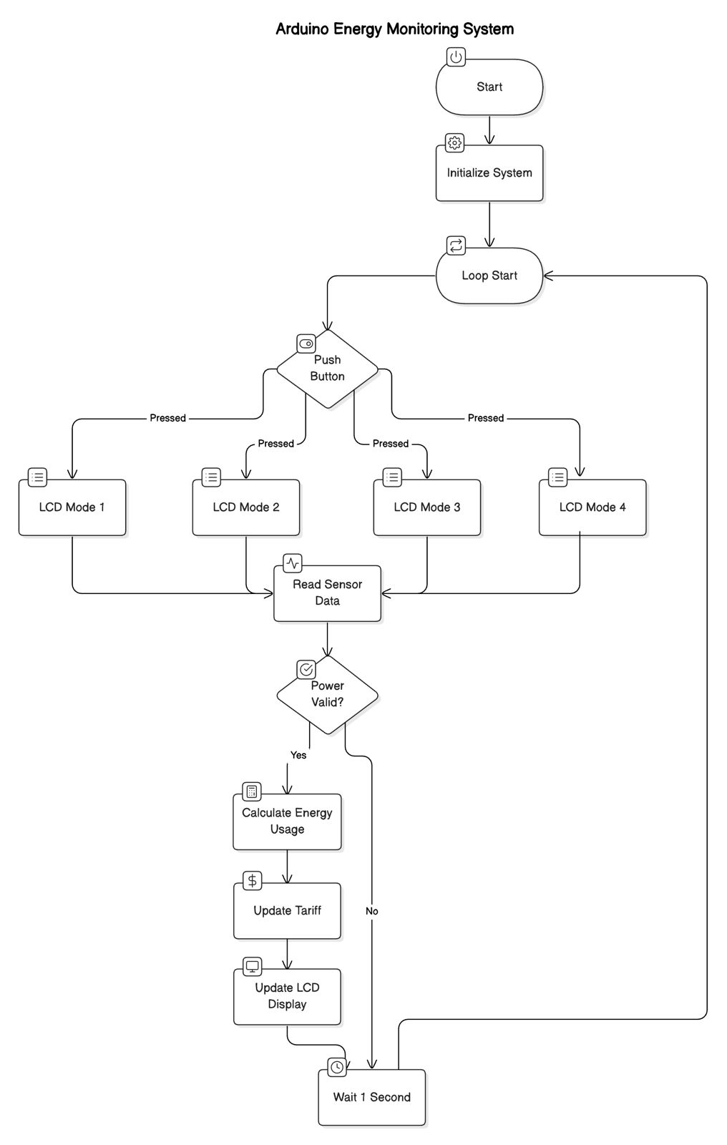

# Hardware Discrption

1. Components Used:
2. Arduino Uno
   * Acts as the main microcontroller, processing data received from the PZEM-004T and displaying it on the LCD.
   * Interfaces with the PZEM-004T using UART communication.
3. PZEM-004T Energy Meter
   * Measures AC voltage, current, power, and energy consumption.
   * Uses a current transformer (CT) for non-invasive current measurement.
   * Communicates with Arduino through UART.
4. Current Transformer (CT)
   * Detects the current flowing through the load.
   * Provides isolation between high voltage AC and low voltage electronics.
5. 16x2 LCD Display
   * Displays real-time electrical measurements.
   * Uses an I2C or parallel interface for communication with Arduino.
6. AC Load (e.g., Light Bulb)
   * The electrical appliance being monitored for energy consumption.
7. AC Mains Power Supply
   * Provides power to the connected load and is monitored by the PZEM-004T.

2. Connections:

|  |  |  |  |  |  |  |  |  |  |  |  |  |  |  |  |  |  |  |  |  |  |  |  |  |  |  |  |  |  |  |  |  |  |  |  |  |  |  |  |  |  |  |  |  |  |
| --- | --- | --- | --- | --- | --- | --- | --- | --- | --- | --- | --- | --- | --- | --- | --- | --- | --- | --- | --- | --- | --- | --- | --- | --- | --- | --- | --- | --- | --- | --- | --- | --- | --- | --- | --- | --- | --- | --- | --- | --- | --- | --- | --- | --- | --- |
| | **Component** | **Arduino Uno** | **PZEM-004T** | **LCD Display** | **AC Mains & Load** | | --- | --- | --- | --- | --- | | **VCC (5V)** | 5V | 5V | VCC | - | | **GND** | GND | GND | GND | Neutral Connection | | **TX (Data Out)** | D4 | TX | - | - | | **RX (Data In)** | D10 | RX | - | - | | **LCD Data Pins** | SDA&SCL | - | SDA&  SCL | - | | **Current Transformer (CT)** | - | CT Input | - | Phase Line | | **AC Line (L)** | - | AC Input | - | Phase Line | | **AC Neutral (N)** | - | AC Input | - | Neutral Line | |

Hardware setup:

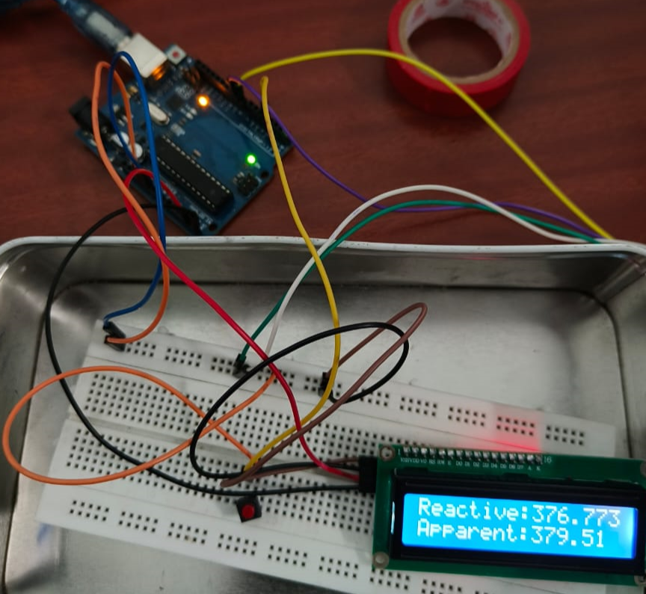

V.RESULTS AND DISCUSSIONS

The Smart Energy Meter was successfully implemented and tested using a standard AC load (light bulb). The system monitored and displayed live energy parameters through a 16x2 LCD interfaced with an Arduino Uno and PZEM-004T energy meter module.

**2. Resistive loads:**

**a) 1A Resistive load:**

i. Voltage and Current:

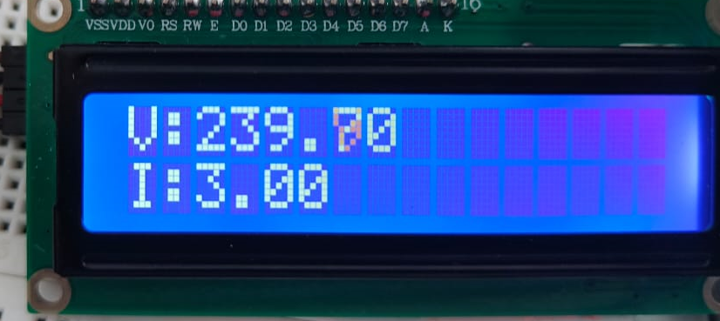

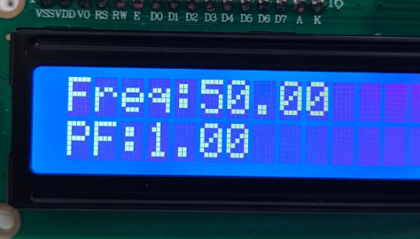ii. Frequency and Power Factor:

iii. Energy and Real power:

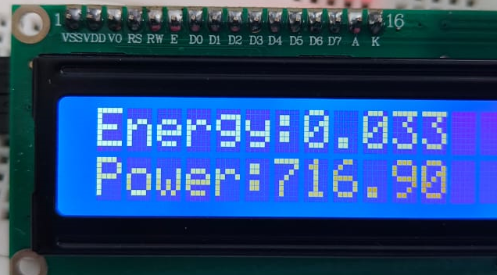

iv. Reactive and Apparent power:

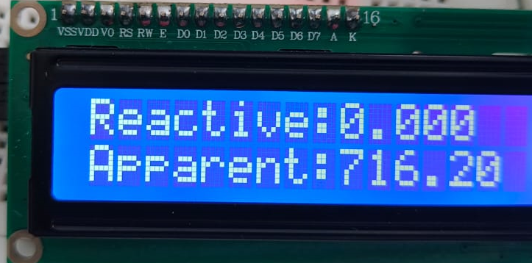

**b) 2A Resistive load:**

i. Voltage and Current:

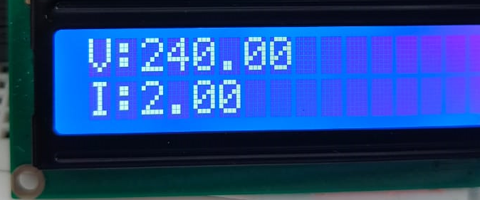

ii. Frequency and Power Factor:

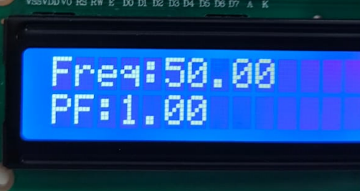

iii. Energy and Real power:

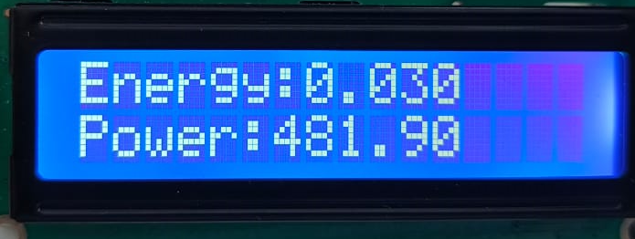

iv. Reactive and Apparent power:

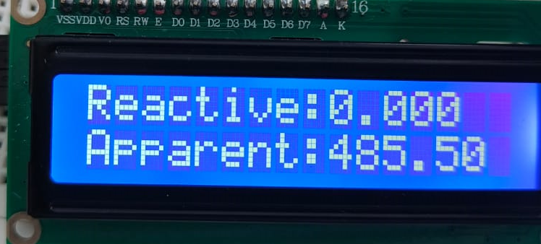

**b) 3A Resistive load:**

i. Voltage and Current:

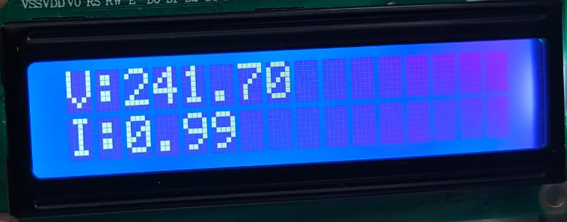

ii. Frequency and Power Factor:

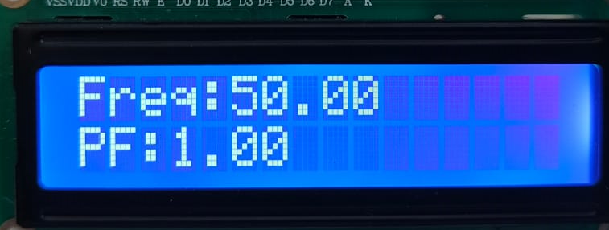

iii. Energy and Real power:

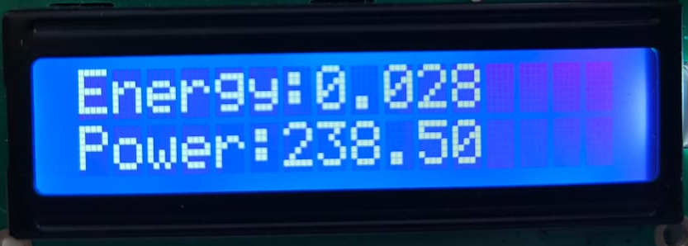

iv. Reactive and Apparent power:

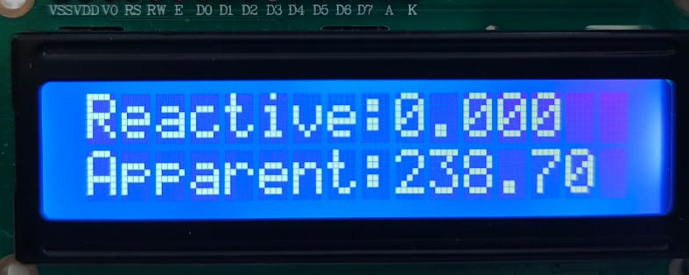

**3. Inductive loads:**

**a) First Inductive load:**

i. Voltage and Current:

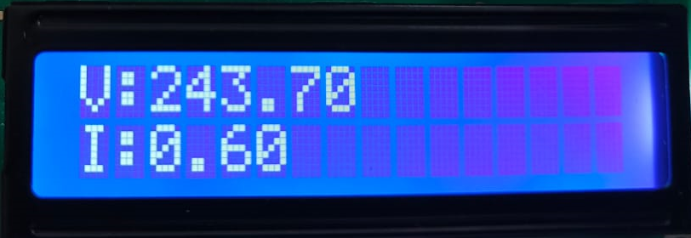

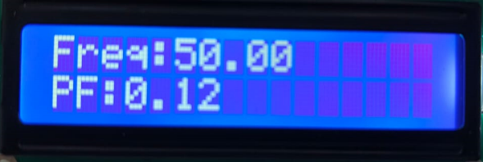ii. Frequency and Power Factor:

iii. Energy and Real power:

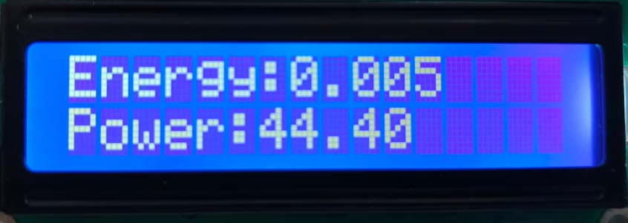

iv. Reactive and Apparent power:

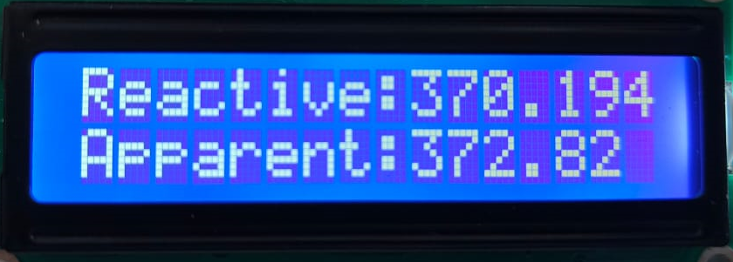

**b) Second Inductive load:**

i. Voltage and Current:

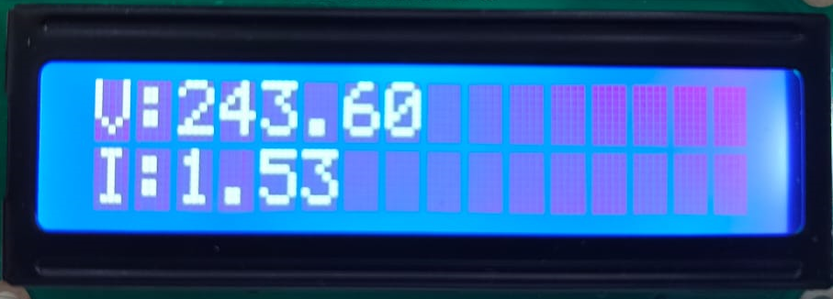

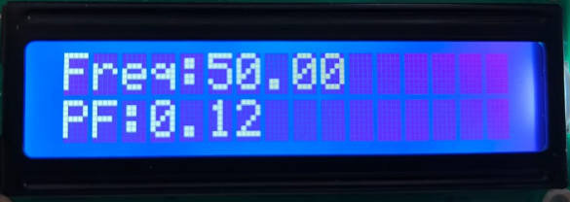ii. Frequency and Power Factor:

iii. Energy and Real power:

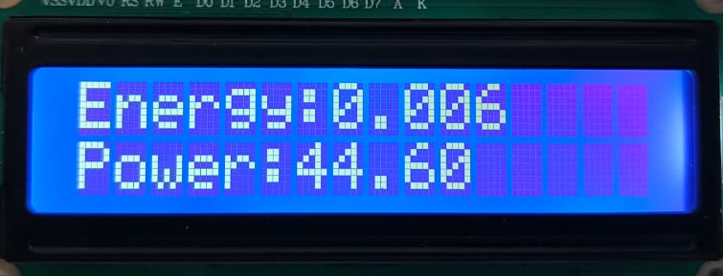

iv. Reactive and Apparent power:

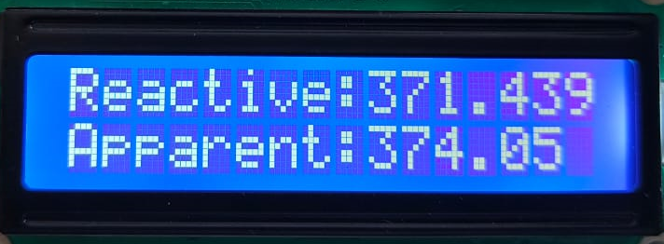

**3. Capacitive loads:**

**a) 0.25A Capacitive load:**

i. Voltage and Current:



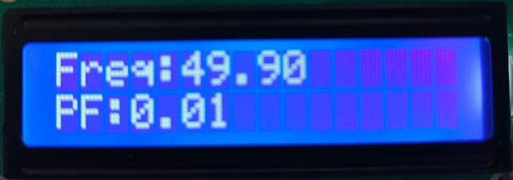ii. Frequency and Power Factor:

iii. Energy and Real power:

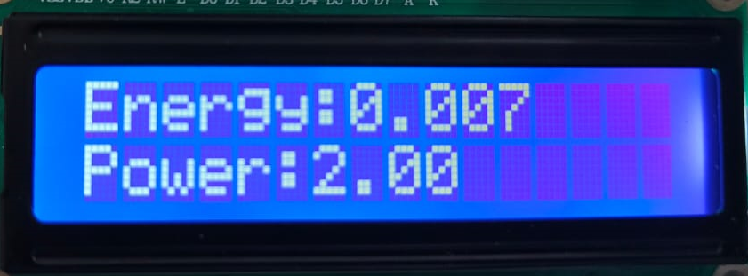

iv. Reactive and Apparent power:

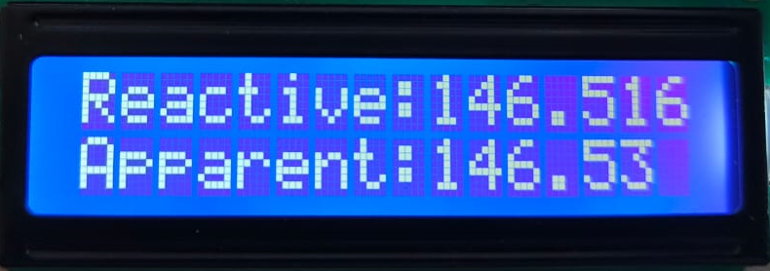

**a) 1A Capacitive load:**

i. Voltage and Current:

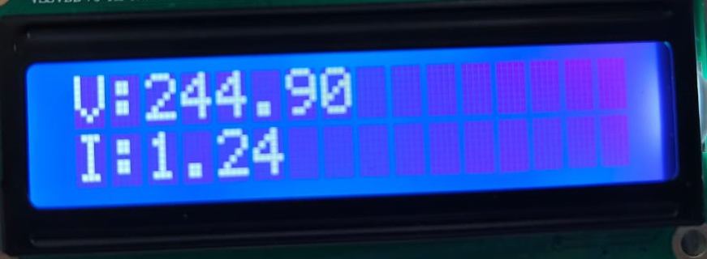

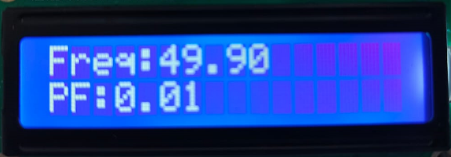ii. Frequency and Power Factor:

iii. Energy and Real power:

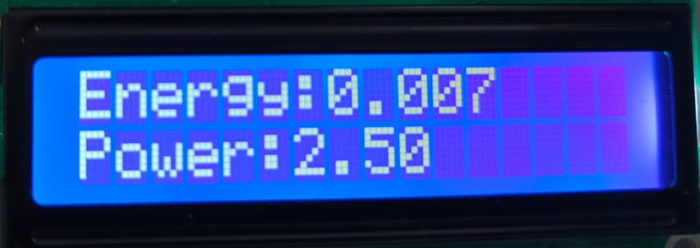

iv. Reactive and Apparent power:

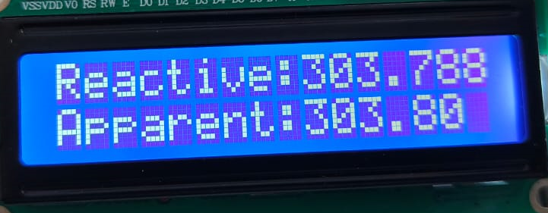

**Units consumed and Tariff display in LCD monitor:**

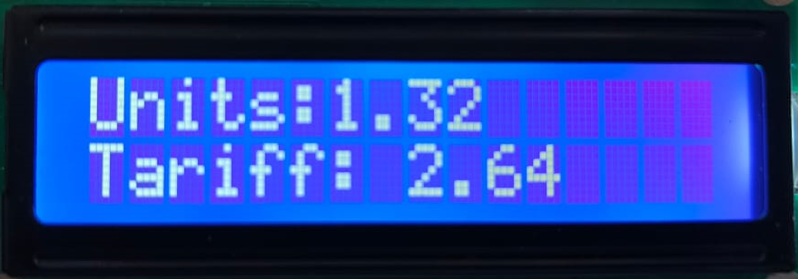

Key Observations:

* Voltage, current, and power values were updated accurately in real time.
* The energy consumed (kWh) accumulated as expected based on the load and duration of operation.
* The real-time tariff was computed dynamically using a variable rate calculation.
* A push-button allowed users to toggle between electrical parameter readings and billing information on the LCD screen.
* No manual reset feature was implemented. Tariff and unit values remain stored and continue accumulating until system power is cycled or reprogrammed.
* Tariff calculation updated in real-time according to predefined Indian slab rates: (each unit is 0.001kwh)
* Below 5 units: ₹2/unit
* 5–10 units: ₹3.5/unit
* 10–15 units: ₹5/unit
* 15+ units: ₹8/unit

Screenshots and Output Verification: The included LCD output photos demonstrate correct display operation during various stages of monitoring and billing. Each screen accurately reflects the internal readings processed by the Arduino uno.

Discussion: This prototype fulfills the essential goals of:

* Real-time monitoring of electrical parameters.
* Automated energy consumption and tariff tracking.
* User-friendly interface with simple mode toggling.

Although no reset mechanism was implemented in this version, the design allows for future enhancements such as automated monthly resets or remote reset commands. Additionally, while this prototype includes a general tariff calculation model, it can be easily adapted to specific billing schemes based on user-defined rates or future integration with centralized billing platforms.

# VI.Conclution

This project aims to develop a Smart Energy Meter prototype that accurately monitors energy consumption and calculates tariffs. The system is expected to provide frequent real-time updates, automate tariff calculations, and reset energy usage after payment confirmation. Improved billing transparency and efficiency will minimize manual intervention. The meter will be designed for easy integration with smart grids and automated billing systems, enhancing energy awareness and promoting efficient energy use.

##### References

1. B. K. Barman, S. N. Yadav, S. Kumar and S. Gope, "IOT Based Smart Energy Meter for Efficient Energy Utilization in Smart Grid," 2018 2nd International Conference on Power, Energy and Environment: Towards Smart Technology (ICEPE), Shillong, India, 2018, pp. 1-5, doi: 10.1109/EPETSG.2018.8658501. keywords: {Meters;Wireless fidelity;Monitoring;Energy consumption;Smart grids;Sensors;Smart meters;IoT;ESP 8266 12E;smart energy meter},
2. E. Rodriguez-Diaz, E. J. Palacios-García, M. Savaghebi, J. C. Vasquez, J. M. Guerrero and A. Moreno-Munoz, "Advanced smart metering infrastructure for future smart homes," 2015 IEEE 5th International Conference on Consumer Electronics - Berlin (ICCE-Berlin), Berlin, Germany, 2015, pp. 29-31, doi: 10.1109/ICCE-Berlin.2015.7391260. keywords: {Energy management;Smart meters;Water heating;Smart homes;Monitoring;Temperature measurement;Energy consumption;Smart homes;Energy management;meter reading}
3. T. T. Walek, "Who is Smart? Smart Metering and Billing System for Prosumer Microgrids With New-Type Multi-Source Energy Meters," 2024 IEEE 12th International Conference on Smart Energy Grid Engineering (SEGE), Oshawa, ON, Canada, 2024, pp. 47-51, doi: 10.1109/SEGE62220.2024.10739450. keywords: {Meters;Renewable energy sources;Power supplies;Microgrids;Production;Power system stability;Particle measurements;Energy efficiency;Time measurement;Smart grids;smart microgrids;renewable energy;prosumer clusters;multi-source metering;smart billing;energy management},
4. M. S. Selvan, R. Ramesh, H. Ragadeepa and T. Sivabalan, "IoT Enabled Smart Energy Meter for Energy Management," 2023 International Conference in Advances in Power, Signal, and Information Technology (APSIT), Bhubaneswar, India, 2023, pp. 280-284, doi: 10.1109/APSIT58554.2023.10201740. keywords: {Meters;Energy consumption;Home appliances;Home automation;Protocols;Information sharing;Real-time systems;IOT;RF;RTDB;WI-FI},
5. G. Mehta, R. Khanam and V. K. Yadav, "A Novel IoT based Smart Energy Meter for Residential Energy Management in Smart Grid Infrastructure," 2021 8th International Conference on Signal Processing and Integrated Networks (SPIN), Noida, India, 2021, pp. 47-52, doi: 10.1109/SPIN52536.2021.9566032. keywords: {Meters;Industries;Energy consumption;Renewable energy sources;Intelligent networks;Signal processing;Smart grids;Smart Electricity Energy Meter;Smart Meter;Internet of Things;Arduino},
6. A. S. Metering, S. Visalatchi and K. K. Sandeep, "Smart energy metering and power theft control using arduino & GSM," 2017 2nd International Conference for Convergence in Technology (I2CT), Mumbai, India, 2017, pp. 858-961, doi: 10.1109/I2CT.2017.8226251. keywords: {Meters;GSM;Relays;Microcontrollers;Sensors;Voltage measurement;Modems;GSM;power theft;Smart meter;Nontechnical losses;power monitoring;tampering;automatic billing},
7. H. K. Patel, T. Mody and A. Goyal, "Arduino Based Smart Energy Meter using GSM," 2019 4th International Conference on Internet of Things: Smart Innovation and Usages (IoT-SIU), Ghaziabad, India, 2019, pp. 1-6, doi: 10.1109/IoT-SIU.2019.8777490. keywords: {Meters;GSM;Microcontrollers;Smart meters;Relays;Light emitting diodes;Energy measurement;Smart Energy Meter (SEM);Arduino;GSM;SMS},
8. R. Sheeba et al., "Real-time Monitoring of Energy Meters Using Cloud Storage," 2021 IEEE International Power and Renewable Energy Conference (IPRECON), Kollam, India, 2021, pp. 1-5, doi: 10.1109/IPRECON52453.2021.9640636. keywords: {Meters;Energy consumption;Cloud computing;Automatic meter reading;Smart meters;Real-time systems;Smart grids;Automatic Meter Reading (AMR);Smart Meter;Long Range Wi-Fi (LoRa WiFi)},
9. v. Manimegalai, V. Mohanapriya, P. R. Raaghav, D. Ranjan, S. Ranjan and S. Selvamurugan, "Leveraging Smart Meter Technology to Combat Energy Theft and Empower Consumption Monitoring," 2024 10th International Conference on Advanced Computing and Communication Systems (ICACCS), Coimbatore, India, 2024, pp. 264-269, doi: 10.1109/ICACCS60874.2024.10716894. keywords: {Meters;Energy loss;Power measurement;Electricity;Transmission line measurements;Smart meters;Real-time systems;Loss measurement;Smart grids;Monitoring;Energy theft;Smart grid;smart meter;Radio Frequency Identification;Microcontroller;Internet of Things;Data security;Energy losses;Distribution supply}.